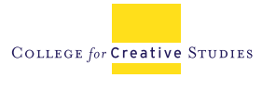
Interview Evaluation Form

Interview Team:________________________
Interviewed Candidate:______________________________
Open Position:_____________________________
Date of Interview:_____________________________
 | POOR  1 | 2 | AVERAGE  3 | 4 | ABOVE AVERAGE  5
SKILLS & RELEVANT EXPERIENCE: Candidate demonstrates competence and relevant skills
TEAM PLAYER: College-collaborative, eager to learn, excited about working at CCS
DEIB: Able to contribute to diversity and inclusive excellence at CCS
VISION & ABILITY TO BRING NEW CONCEPTS & TECHNIQUES TO CCS: Able to articulate the future opportunities
PROFESSIONALISM & COLLABORATION: approachable and demonstrates the ability to collaborate well with others
TOTAL POINTS

